Fast Food in France: The Good, The Bad and The Ugly
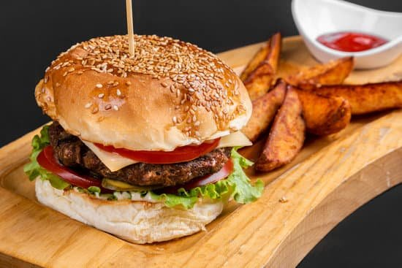
Fast food in France is famous. It is a fact that every country has some food specialties. However, the visitors want to explore new fast foods on every trip. This guide is for you if you are also on the hunt for fast food in France.
Burgers are the Essence of Fast Food
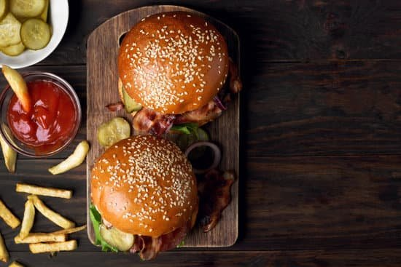
According to the definition, fast food swells quickly. Burgers are one of the highly ranked fast foods, and it has different varieties.
US BURGERS Franchises
There are many biggest brands of burgers, like Mcdonald's and Burger king. However, last year a US brand also arrived in France and built excellent franchises with good reputations. You can get healthy alternatives in Burger franchises than unhealthy food that corresponds to your diet.
What if you don't like burgers?
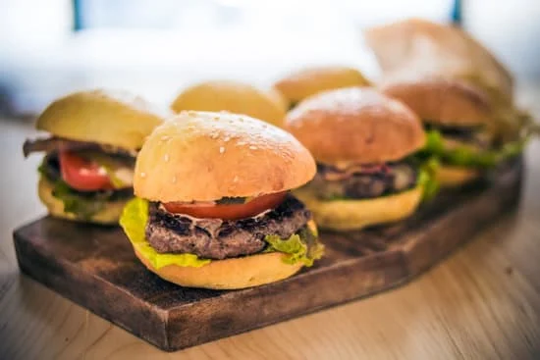
Many of us preferred to have burgers only sometimes. So here are some alternative fast foods in France that can be healthy and you can enjoy.
Kebabs
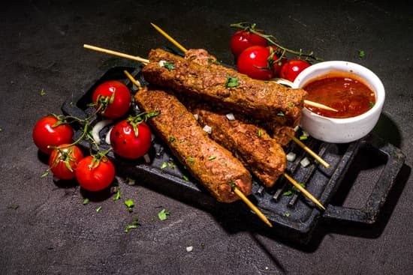
There are plenty of points across French cities that offer different kinds of prepared fast foods. So you can divert your taste according to your liking. However, Kebabs consist of veal grilled on a spit. It has a variety, including sauces, vegetables, and fries. You can eat it with thick bread or tacos. It also comes with STO.
Sushi
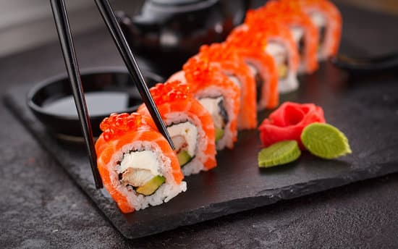
If you can eat raw fish, then you can try the inevitable. There has been a chain of sushi places in France since 1998. Sushi shops can conquer French astronomy with quality and massive variety. You can get different limited edition boxes of sushi according to your taste. The original creation of sushi was only reserved for the limited editions.
Sandwich shops
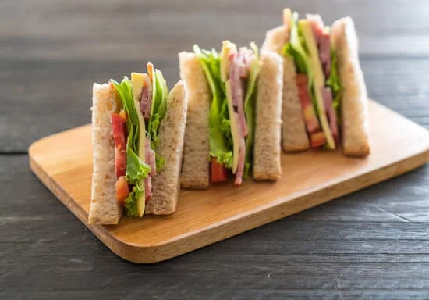
If you want to get cold or hot sandwiches, you can find the Subway Franchise everywhere in France. They offer a great variety of sandwiches. You can choose the type of bread you want along with fillings among paul, La Brioche Doree, and many more. Paul is one of the practical and chic choices to eat in French sandwiches.
France has best-selling sandwiches, and you can taste a wide variety. You can also choose a diverse variety of dessert menus to finish your meal.
Food Trucks
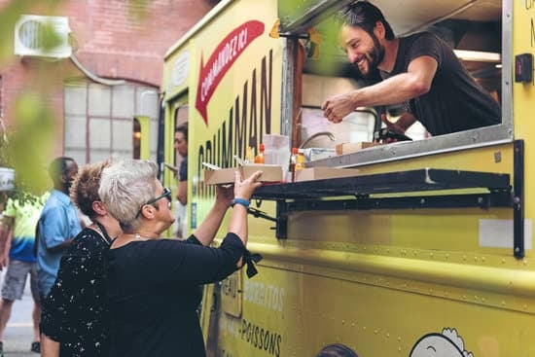
Food Trucks are popular all over the world. Similarly, you can also see the number of food trucks in the streets of France. The primary principle of food trucks is to serve society by moving around the streets. It is something in fast food that is available for everyone. However, many of us need clarification about how to find food truck restaurants? So it is a fact that food trucks are not listed on directories or sites where you can see them. The best way is to install the application Track the truck and find the perfect food truck near you in France.
Salad bars
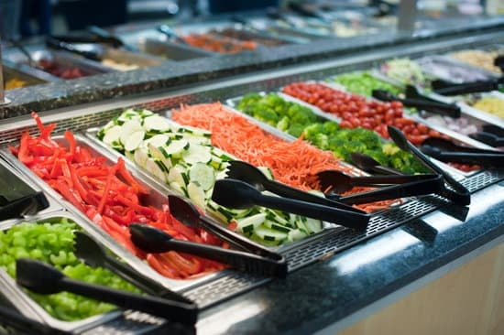
Different salad bars like eat salad, or green Sur Mesure offer a variety of salads in France according to your taste. If you want to have healthy fast food items, then complete the menu with salads as it also fulfils the idea of fast food.
Now grab your favourite fast food in France and enjoy the meal.

